**24.AUTOMATION TESTING USING SELENIUM TOOL FOR SEARCH ENGINE**

**M.GEETHA SRI**

**192110718**

**AIM :**

To execute Automation testing using Selenium tool for opening search engine.

**PROGRAM** :

package chennai;

import org.openqa.selenium.By;

import org.openqa.selenium.WebDriver;

import org.openqa.selenium.chrome.ChromeDriver;

public class second1

{

public static void main(String[] args)

{

System.out.println("hai");

System.setProperty("webdriver.chrome.driver","C:\\manik\\CSA37 Lab

details\\Sellinium and junit\\selenium

jar\\chromedriver_win32\\chromedriver.exe");

WebDriver driver = new ChromeDriver();

driver.get("https://www.google.com/");

//TODO Auto-generated method stub

}

}

**OUTPUT:**

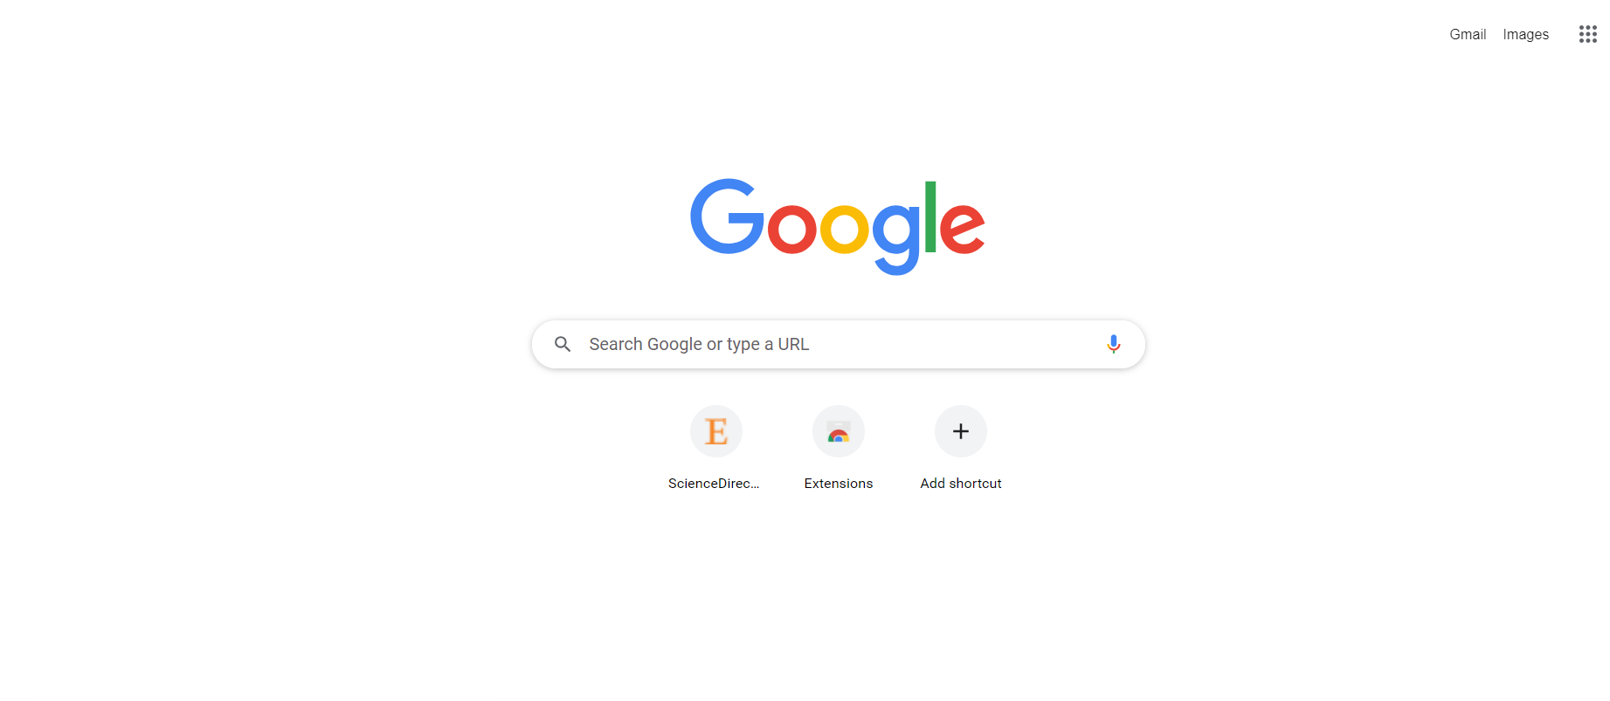

**RESULT:**

Hence Automation testing for opening search engine is Executed successfully.